Screen%20Shot%202017-01-05%20at%209.55.14%20PM.png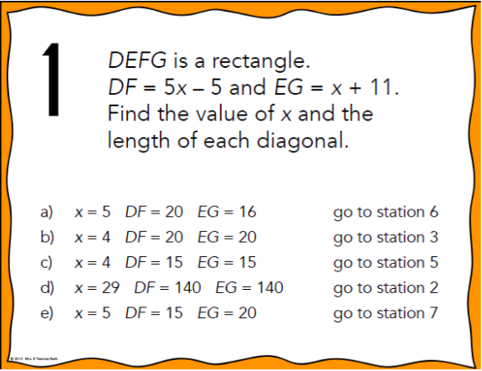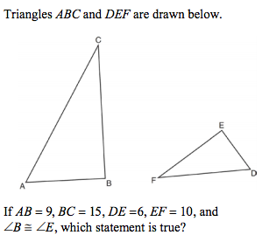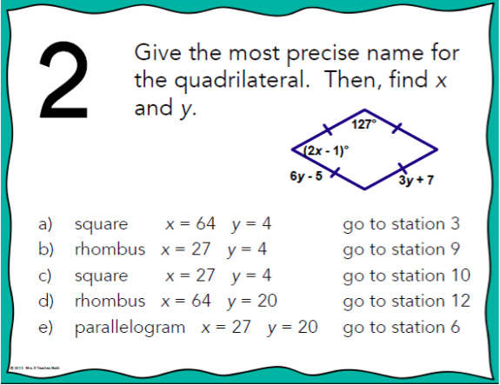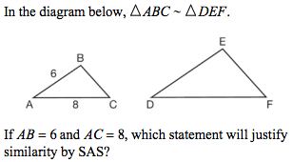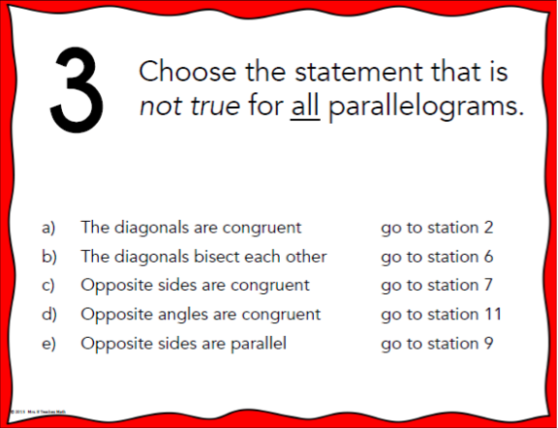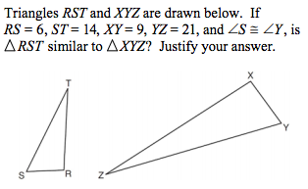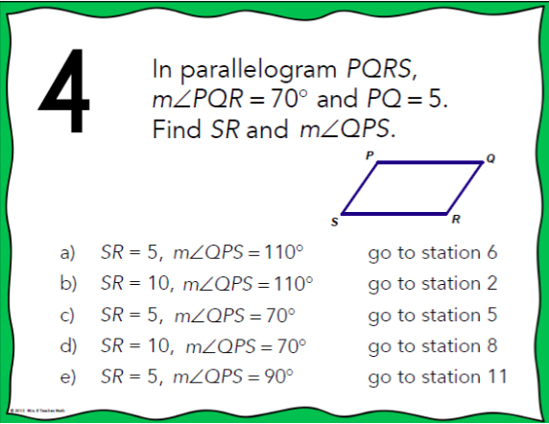Screen%20Shot%202017-01-05%20at%2010.19.20%20PM.pngScreen%20Shot%202017-01-05%20at%209.59.22%20PM.png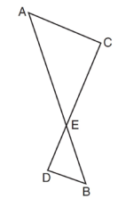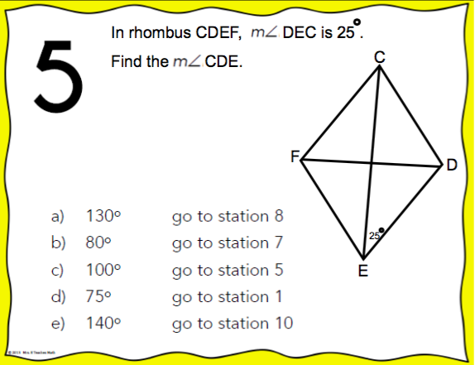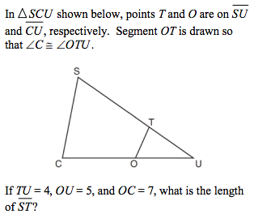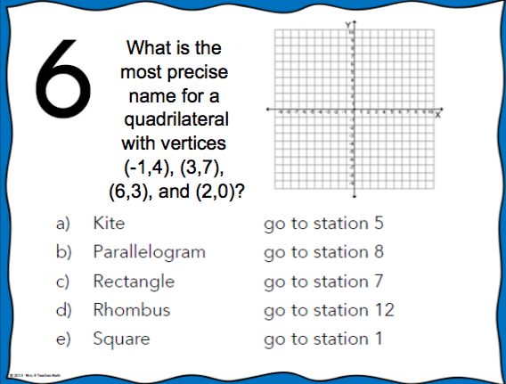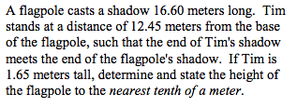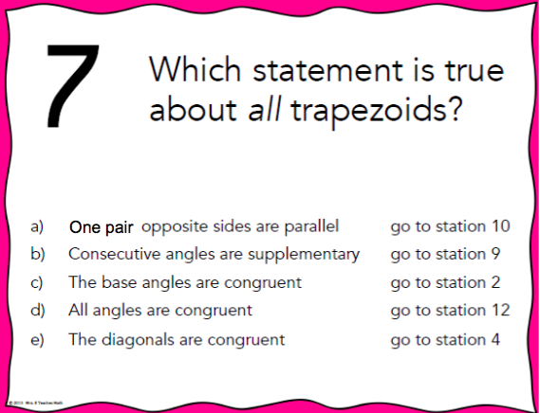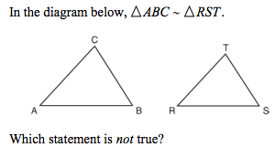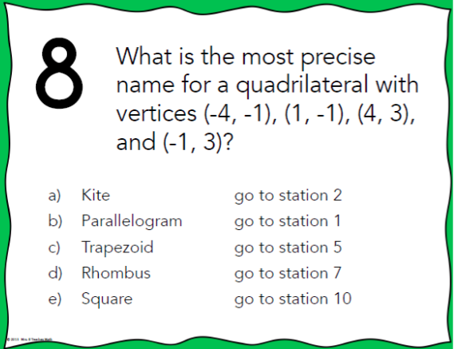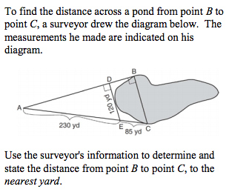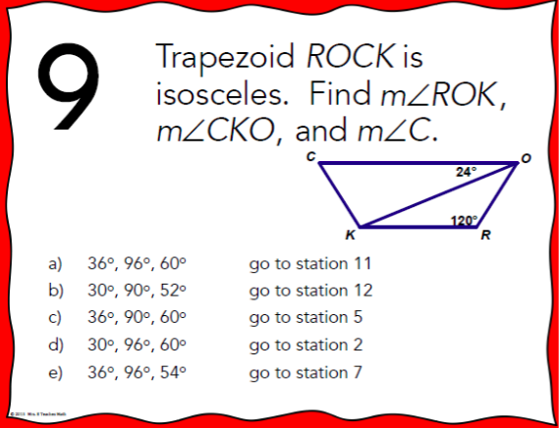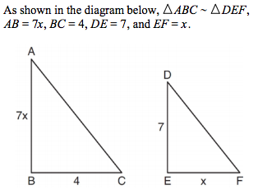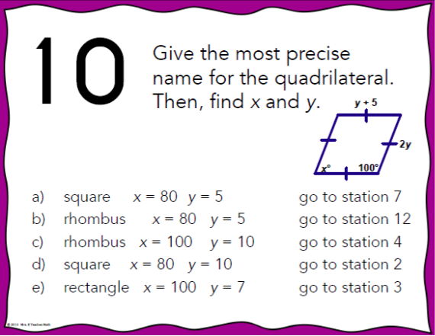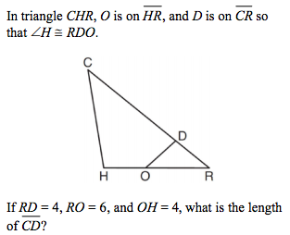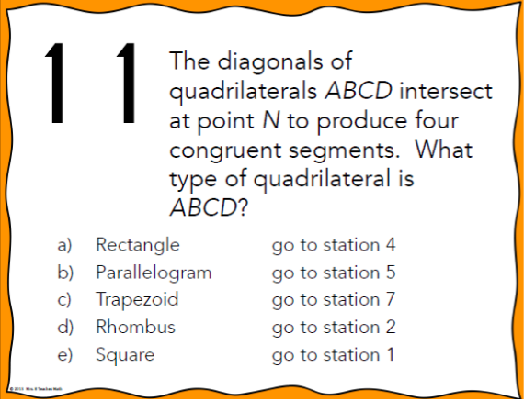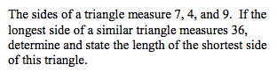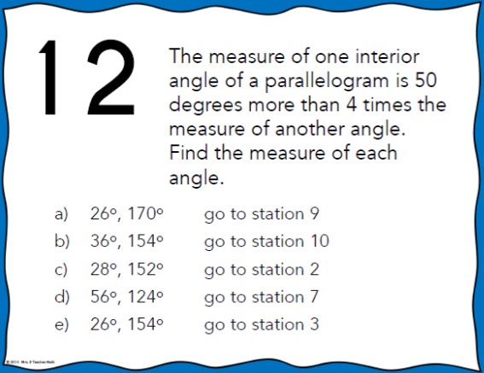

7

10

20

5

70

7

10

20

70

DE = 9, DF = 12, and ∠A ≅ ∠D

DE = 8, DF = 10, and ∠A ≅ ∠D

DE = 36, DF = 64, and ∠C ≅ ∠F

DE = 15, DF = 20, and ∠C ≅ ∠F

DE = 8 DF=10 and ∠C ≅ ∠F

Yes because of SAS~

Yes because of AA~

Yes because of SSS~

No because no ∠’s are ≅

No because no sides are proportional

7

10

20

70

5.6

8.75

11

9

15

6.6

4.2

1.7

27.9

18.0

7

10

20

70

164 yards

85 yards

125 yards

315 yards

210 yards

Find the length of *AB*.

2

14

28

4

6

11

2

15

6

10

¼

36

144

4

16